Introduction to Plate Boundaries
I hope you have never been in a car accident, but I know we all have seen one in our lives. If you have watched many movies, you almost certainly have. Have you noticed how even when the car is no longer at the accident site, you can tell what happened to it - like where it was impacted, how fast it was going (or the other car was going), and what part was hit first? Even without impacts, perhaps you can piece together what happened when a scratch shows up on the side of the car. As tectonic plates of the earth, or giant pieces of the earth's crust, move and crash into each other, similar tell-tale signs show up to give us some ideas about how they move with relation to each other.

Introduction to Plate Boundaries
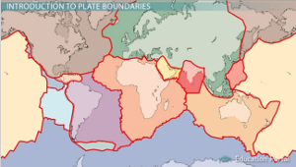
The red lines show where the crust is divided into several plates
The theory of plate tectonics states that the crust of the earth is broken up into large pieces, or plates, that move around by floating on top of the liquid layer of the earth known as the mantle. This process is driven by convection currents within the mantle. Convection currents are formed by hot magma near the core rising towards the surface, while cooler magma near the crust sinks, setting up a current that causes the plates to move. These currents are the primary driving force behind plate movement. This theory was the result of decades of work and observations made of the earth's surface. It still is the first model to neatly explain all the pieces of data scientists couldn't explain when they thought the surface of the earth was stationary.
The map may seem confusing at first, but the main thing is that the colored lines show the lines where the crust is broken up into many different plates. Most are named after the continents that are contained on them.
Some plates are entirely oceanic crust, or crust under the ocean, while others are a combination of oceanic and continental crust, which is crust of the continents. The boundary where two separate plates meet is where all the action occurs and is called a fault. A fault is a crack in the earth's crust resulting from the movement of the two plates.
Getting back to the example of cars, when two cars are next to each other, there are three possible ways for the cars to move with relation to each other. Plates act in a similar manner.

Divergent Boundary
The first way two cars can move relative to each other is in divergent directions, like passing a car going the other way. Plates also can pull apart from each other. This is known as a divergent boundary. A divergent boundary is a fault where the two plates are moving away from each other.
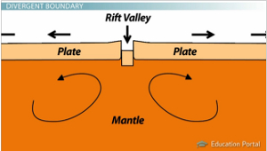
Rift valleys develop when a continent is broken apart by a divergent boundary
Now, as plates pull apart, several things may occur. First of all, volcanic activity is common in these areas since mantle easily moves to the surface through the thin, fractured rock as it separates. Volcanoes are a sign of a divergent boundary. This happens all along the mid-ocean ridge where magma is constantly streaming to the surface, creating new ocean floor as the plates separate.
If a continent happens to be a place where a divergent boundary occurs, then the continent will begin to be torn apart as the sides of the plates separate, creating a rift valley. The African Rift Valley in East Africa is an example of this occurrence. Eventually the ocean will separate East Africa from the rest, making a large island.

Convergent Boundary
A second way cars interact (unfortunately) is by colliding. When cars impact each other or another solid object, the energy is transferred to the cars themselves, showing up as dents, ripples, or cracks. Plates also show telltale signs of colliding, too, depending on the kind of crust colliding.
Remember that at divergent boundaries, new crust is being made, but the earth is not getting larger. Why not? Well, at the opposite ends, crust is being pushed into the earth's interior by colliding plates and being re-melted at the same rate new crust is formed. This happens at a convergent boundary. A convergent boundary is a boundary where two separate plates are pushing into each other.
There are two kinds of surface features that are associated with a convergent boundary. The first is a deep ocean trench that forms a line of the two colliding plates. One plate made of oceanic crust can slide down underneath another plate, forming this narrow, deep trench. This happens because oceanic crust is denser than continental crust, making it more likely to be pushed back into the mantle. These trenches are the deepest places on the face of the earth, extending over 30,000 feet below the ocean surface. You could take Mount Everest and sink it in the Mariana Trench, the deepest point in the ocean, and still have a mile to the surface of the ocean. That's deep!
As one plate is forced under the other one, it begins to melt, and a line of volcanoes forms in a parallel line to the trench. If the other plate is oceanic crust, the line of volcanoes will become islands, like the Philippines, and if it is continental crust, then it will become a line of volcanic mountains, like the Cascade Range in the western U.S. or the Andes Mountains in South America.
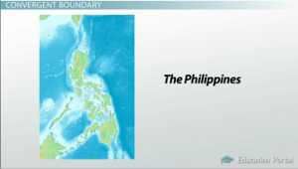
The Philippines islands are the result of a convergent boundary
If both plates are continental crust, the plates will crumple up as they collide, forming a high mountain range, much like the Himalayas. Continental crust is less dense than oceanic crust and does not get forced into the mantle. The crumpling of the continental crust is similar to two cars colliding, as in the example from earlier.
No matter which type of crust is colliding, you will see volcanic activity if one is oceanic crust because the more dense oceanic crust is pushed down into the mantle. As it is forced down, it begins to remelt, and the magma forces its way to the surface to form the volcanoes. All types will form strong earthquakes, forming from the plates grinding together as they slide under.

